**Task No. 1:** **Add a view called Managers in the Northwind database that shows only employees that supervise other employees.**

**Solution:**

create view Manager as

select a.FirstName+' '+a.LastName as Employee,b.FirstName+' '+b.LastName as Manager from Employees a inner join Employees b on a.EmployeeID=b.ReportsTo

**Output:**

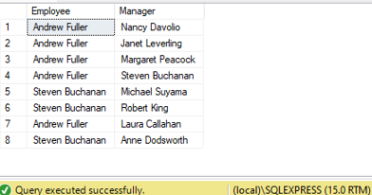

**Task No. 2:** **Create Northwind view called “Products by Category” based on the columns CategoryName and ProductName.**

**Solution:**

create view [Products by Category] AS

SELECT Categories.CategoryName, Products.ProductName

FROM Categories INNER JOIN Products ON Categories.CategoryID = Products.CategoryID WHERE Products.Discontinued <> 1

**Output:**

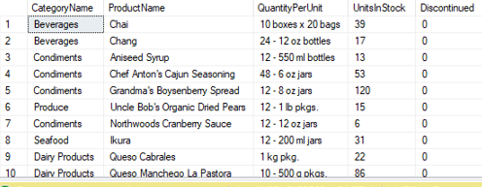

**Task No. 3:** **Create a view that shows a table that list all the publishers and store names using pubs.**

**Solution:**

create view [List of Publishers and Stores] as

select [Pub_Name],[stor_name] from Publishers,Stores

**Output:**

select * from [List of Publishers and Stores]

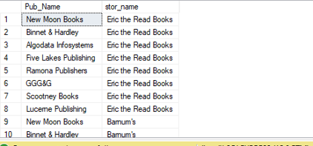

**Task No. 4:** **Create a view that shows a table that list all the authors and store names using pubs.**

**Solution:**

create view [List of Stores and Authors] as

select stor_name ,au_fname+' '+au_lname as Author from Stores,Authors

**Output:**

select * from [List of Stores and Authors]

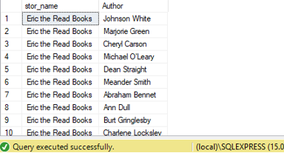

**Task No. 5:** **Create a view the amount total amount spend by customers.**

**Solution:**

create view CustomersTotalAmountSpend as

select Customer,AmountSpend from

(select ContactName as Customer,orderid from Customers inner join orders

on customers.customerid=orders.customerid)table1 inner join

(select orderid,sum(quantity*unitprice) as AmountSpend from [Order Details]

group by orderid)Table2 on table2.orderid=table1.orderid

**Output:**

select * from CustomersTotalAmountSpend

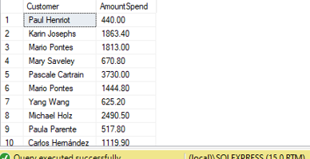

**Task No. 6:** **Create a view for customers shippers information.**

**Solution:**

create view CustomerShipperInfo as

select contactname as Customer ,shipperid,shipname,shippers.companyname,

shippers.phone from customers left join orders

on customers.customerid=orders.customerid

left join shippers on orders.shipvia=shippers.shipperid

**Output:** select * from CustomerShipperInfo

